Keywords: ClearCase, Multisite, replica, epoch, oplogs, registry, Ruby On Rails, XML-RPC, MYSQL

Abstract: Multisite packets’ exchanges happen almost exclusively over the net, so the imports latency is minimized. Everyone expects and mandate a predictable turnaround. Remote admin is challenged when errors occur on the WAN. The cryptic nature of the distributed logs, notifications and epoch tables, working over many time zones, different IT policies, make troubleshooting an obscure art. Ultimately the development schedules are affected. Most distributed products have a centralized control tool in their toolbox. Crosync brings such a tool to Multisite.

Introduction:
Multisite is generally considered an old product meant to exchange packets by mail, email and sometimes over the net. However, we never saw replicas sent by mail or email – network general availability and especially broadband makes the transport phase to happen online only. Remaining faithful to its original purpose – to both allow distributed development, via replicas, and avoid write conflicts, via mastership, it still keeps replicas consistent. It is expected all replicas are synchronized at all times.
Organizations are no longer working on just a single VOB that hold “everything”. They are typically split and new VOBs and replication strategies are created after the kick of meeting for new product lines. That is often part of the CM plan. Complex symbolic links are maintained between VOBs, directories or files. The VOBs segmentation comes at the very same time with the requirement for guaranteed connectivity. Virtual teams working in virtual space are the norm, so ever smaller parts of the projects are worked on in multiple locations with daily or even hourly exchanges.

VOBs replication control increases exponentially the administrative efforts – they now take a big toll as administrative efforts and therefore cost.
While ClearCase’s general administration (VOB, views, metadata, branches) is well understood and mostly locally managed – per registry - the typical multisite issues, do not benefit from an easy to use toolset.
There is no such thing as multisite registry.
Even when email notifications are received, administrators are not readily available and there are no quick fixes. Best practices implementation suffers. Since most projects’ development are today at the crossroads between development, project management, QA, release control and deployment, a single tool / dashboard is needed to assist multisite administration, in order to provide a quick and consistent image of the replication status, progress on complex replication topologies. The dynamic timing of the three phases of the synchronization process needs a better tool to help investigations.

Implementation Goals:
- Centralize control over all multisite exchanges,
- Offer simplicity - to identify multisite issues and trends from a single point of contact – a dashboard service, running on any browser,
- Save time to troubleshoot and fix multisite issues,
- Employ open source tools: e.g. Ruby on Rails, Mysql, and Linux, in order to offer decent costs and stability.

Present Architecture – Technical Challenges
Replicas and epoch tables need to be regarded as the main entities of a distributed file system. In all commercial or open source Operating Systems, the access to FS’s clusters and allocation tables is restricted and not even very technical administrators are required to “re-assemble” files out of the system entities, nor to even be aware of the file systems inner logic or mechanics. While the multisite fundamentals are solid, the operational complexities - topologies, epoch tables, and especially pressures are overwhelming many admins.

That makes the Multisite an unfinished product – the two missing parts:
- No exposed APIs (for multisite) that would allow the technical administrator access to compose and run maintenance scripts - to both test and maintain the repositories’ consistency.
- The challenges presented by the complexity of the epoch tables in very diverse situations when the replicas distributed topology changes based on very dynamic requirements – mandated by the development or IT. It is as if the Windows/Linux administrator is required to (very dynamically) split and reassemble volumes based on engineering projects vs. performance, estimates and statistics.

The current working model for a distributed, multisite replicas management could be described as in the figure below – the admin is logging into many servers over a dispersed geography, penetrating firewalls in response to the email notifications – mainly a failure in imports (packages are lost). Or inquire local and remote registries and troubleshoot incidents, run regular maintenance jobs – constantly checking the replicas’ health. “multiool lsepoch -actual” helps, but still most admins need to log into remote servers.

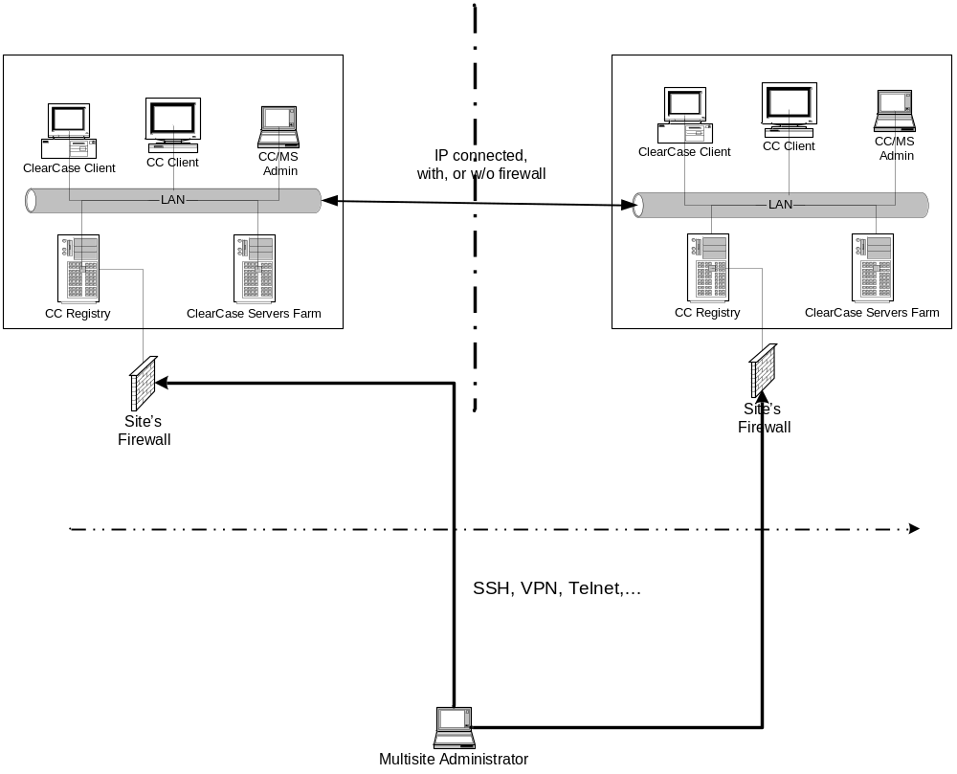Figure 1: The “Classic” Multisite Administration – the admins loging into multiple servers, inspecting local registries and oplogs

The multisite epoch tables and lsreplicas syntax are well documented in IBM Rational documentation.

In order to bring under the same roof the multisite admin, the Crosync’s solution is targeting the implementation of the following functions:
- Centralize the pertinent information related to Multisite (replicas dispersion), all the working tables (user, sites, hosts, replicas, oplogs, connections) are shaping the current schema.
- Collects information on Multisite logs (lsvob, lsreplica, lsepoch) quasi real-time and all the shipping servers are hosting an XML-RPC agent (or some other exchange mechanisms) that is pushing epoch tables logs to the server (not completely implemented).
- Presents to the stakeholders a manageable synopsis of the installation: entities (replicas, epoch tables) and troubleshooting events. The information is updating the current database and renders to the user results in a format that enables fast troubleshooting, unlike the typical epoch tables that needed to be manually requested, compared and investigated.
- Allows remote multisite administration from a single location. The multisite admin is able to issue corrective actions from a web browser – the commands are relayed to the VOB servers and executed. Results are reported back to the administrator (not yet completely implemented). There would be no need to continue the present practice of running lsepoch commands on different servers in order to investigate import incidents and ultimately to discover the real cause.

The logs extracted from ls type utilities (lsvob, lsreplica and lsepoch) were parsed and the corresponding tables were populated. The conversion between such linear logs to a relational database model was therefore completed – ie. from /app/models/site.rb, the lsepoch_scan method:

Listing 1: Parsing epoch logs

def lsepoch_scan(params)

# row_replica field should also match the "Actual" epoch list...
# we let site_id to exist for tagging purposes, but will not be part of the record
rules = Hash[ :tag => "For VOB replica ",
:row_replica => "plog IDs for row ",
:host_id => "",
:site_id => "",
:process => "",
:column_replica => "",
:opnumber => 0,
:oid => " oid:"]

_epoch = Hash.new
_esave = Hash.new
lsepoch = params[:lslog]
# testing the log files
# used only while debugging
if _debug
if File::exists?("tepoch.log"); File.delete("tepoch.log"); end
file = File.new("tepoch.log", "w")
end
# Reading the lsreplica file will not create new entries in the 'vobs' and 'hosts' tables
# it will update entries where tag and hostname are matching
until (_line = lsepoch.gets).nil? do
# scanning the "columns" (hash' keys) for each line
if _line.match(rules[:tag].to_s)
# clear the _epoch hash
if !_epoch[:tag].nil?; _epoch.clear; end
_epoch[:site_id] = params[:id].to_i
m = /(.+)\"(.+)\"/.match(_line)
_epoch[:tag] = m[2]

elsif _line.match(rules[:row_replica].to_s)
# :row_column_id and :host_id are not yet the IDs!!! - they represent now only the string value
m = /(.+)\"(.+)\"(.+)\@.(.+)\)/.match(_line)
_epoch[:row_replica] = m[2]
_epoch[:host_id] = m[4]
elsif _line.match(rules[:oid].to_s)
m = /(.+)oid:(.+)=(\d+)(.+)\((.+)\)/.match(_line)
# skip the deleted replicas !!!!
if /.deleted/.match(_line).nil?
_epoch[:oid] = m[2]
_epoch[:opnumber] = m[3]
_epoch[:column_replica] = m[5]
# save & restore the literals for the next iteration
_epoch.each_key { |skey|; _esave[skey] = _epoch[skey] }
lsepoch_identify_ids(params, _epoch)
# write the record if not deleted
lsepoch_update_epoch_table(_epoch, params)
if _debug
file.puts _epoch.to_a
file.puts "++++++++++++++++++++++++++"
end
# restore the _epoch hash
_epoch.each_key { |skey| ; _epoch[skey] = _esave[skey] }
end
end
end
lsepoch.close
if _debug ; file.close ; end
# a leap of faith - delete all the :process => "Info"
Oplog.delete_all(:process => "Info")
# assigning stray cats (hosts) to newly created "sites"
lost_and_finally_found(params)
end

Epoch logs entries are analyzed and corresponding database records are updated

As soon as all logs are uploaded and parsed, the oplog records are tagged with “Resident”, “Export” and “Import” – reflecting the typical rows’ significance from lsepoch commands – that allows the issues identification and tagging – e.g from app/models/oplog:

Listing 2: Identifying export issues

def epoch_export_issue(record)
if record[:process] != "Exported"; return false; end

_op_resident = self.find_by_oid_and_process(record[:oid], "Resident")

if _op_resident.nil?; return false; end # not enough data - can not report an error!

_site1 = Site.find(_op_resident[:site_id])
if _site1.nil?; return false; end; # not enough data - can not report an error!

# find the resident's entry site_id of the column_replica - if it doesn't exist, raise an error!!!
## _res_vob = Vob.find(record[:column_replica])
## _res_host = Host.find(_res_vob[:host_id])
if (_op_resident[:opnumber] > record[:opnumber])
return true # we are behind!
end
return false
end

Export issues are typically easy to find, since the diagnostics are done at the “source”.

In the tool’s presence, the same admin receives an updated snapshot of the packets exchanged:

Figure 2: Global Infrastructure Layout – the Crosync solution

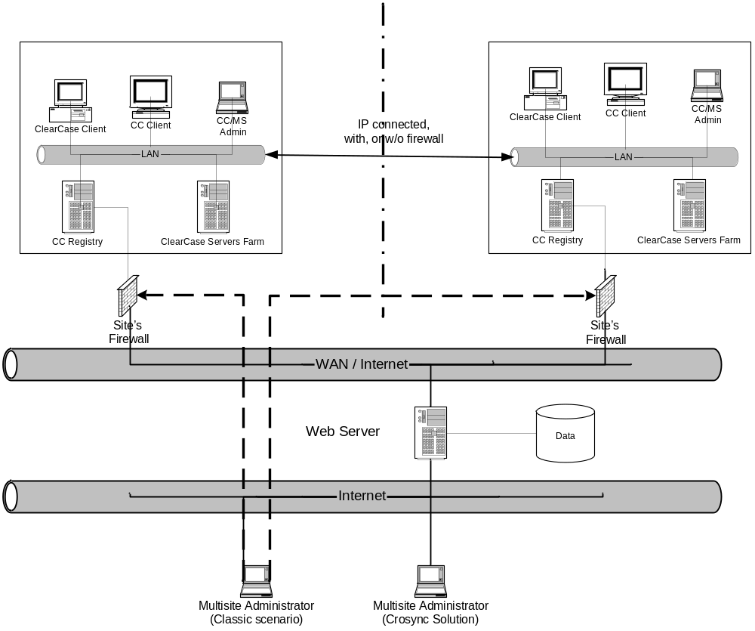

De-facto multisite registry - while the “classic” administration recommends remote logins into each server, the Crosync solution achieves the data persistency goal by consolidating all the pertinent multisite information into a single database.

Physical Database Representation:
In order to achieve the logs translation to a persistent representation, the following database structure was put to use – data is collected from the logs and placed in Figure 3.

Sites, Hosts and Vobs (actually the replicas names) tables are self-explanatory; the double arrow from oplogs into vobs represent the relationship between “row_replica” and “column_replica” into the replicas table (tagged as vobs).

Figure 3: Class Diagram

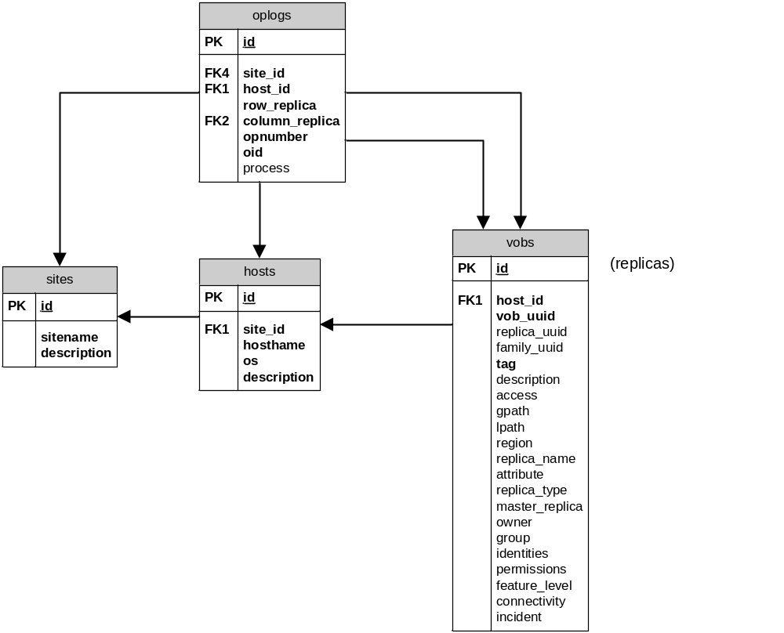

The Data Model – Crosync’s database layout

System Architecture
Ultimately the systems functional architecture could be depicted as in Figure 4 – local agents deployed on one machine per ClearCase registry are providing the log feed to Crosync server (a regular Linux server). The outbound link works on the port 80 (it’s like an web app).

On the inbound link a port must be opened by the IT – it could be one standard port used by Multisite solutions deployed across the WAN. The server is sending change epoch commands when import incidents positively occur. It could also query the VOB server any information on the status of the shipping bay, local logs, registry information – one stop shop – administration for the distributed ClearCase deployment.

Figure 4: Functional System Architecture

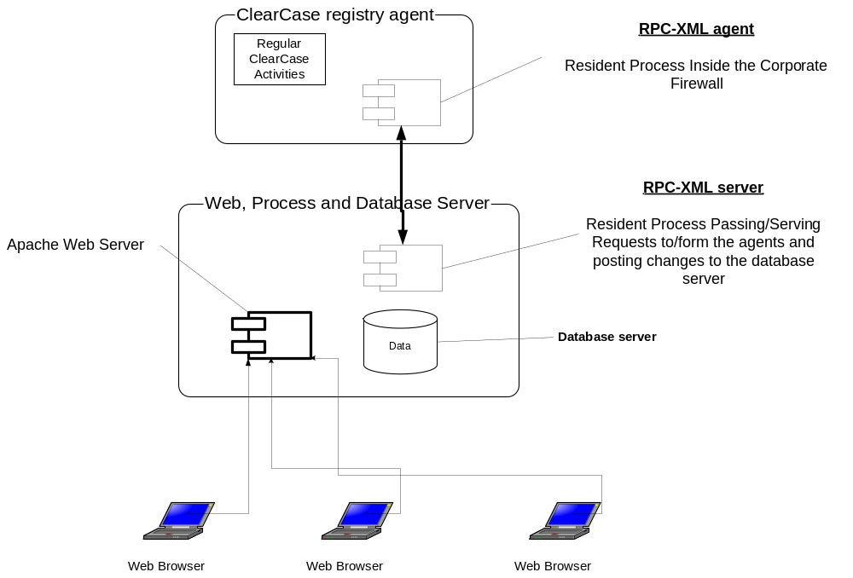

The Open Source – widely available technologies and tools - COTS are shaping up the Crosync solution.

Technology needed to deploy the Crosync solution
The solution is developed using open source, off the shelve technology:
- A Linux machine – Ubuntu 8.04 or above
- Ruby (version 1.8.7)
- Rails (version 2.0.2) - http://rubyonrails.org/
- Mysql (rev. 5.0.14 or above), and the two plugins:
- Goldberg generator
- ActiveScaffold
Caveats:
Rails is developed very aggressively; also the plug-in are trying to keep pace with rails, so (long term) spending some time and getting the proper “alignment” requires some effort.

The “Easy Button”
The Crosync solution could be downloaded from Crosync github repository - it contains both plugins. The items 1 through 4 are easily available. Once Rails is installed, you can download rev. 2.0.2 using gem: “gem install –v=2.0.2 rails”

References
IBM ClearCase Multisite documentation –
http://www-01.ibm.com/software/awdtools/clearcase/multisite/
Crosync Software - http://github.com/crosync/crosync

Credits
- Goldberg generator - https://github.com/urbanus/goldberg
- ActiveScaffold – http://activescaffold.com/
- Ruby On Rails - http://rubyonrails.org/
- Mysql – http://www.mysql.com
- Ubuntu – http://help.ubuntu.com

Closing Remarks
Multisite is a solid product – if all’s well, the replicas are generated correctly and a strict mastership policy is observed, the operational issues are rare and when they happen, experienced admins are able to investigate, find the issues and fix the problems.
However, the VOBs fragmentation, large size, project driven synchronization policies and diverse network topology are all sources for compounded side effects.
Under such an ever more complex scenario, there is no one single methodology to follow and quick fix to apply – Crosync, as a tool is needed to maintains the whole picture in one place, pinpoint and investigate symptoms with ease, all for restoring a consistent operation through a net/web service.

